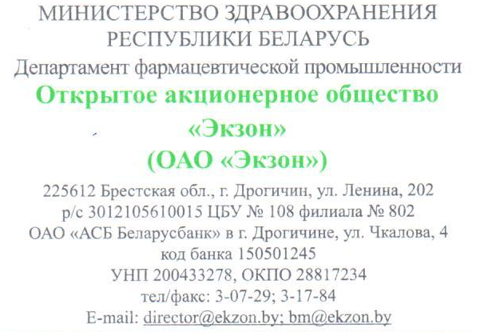

**PRODUCT-LIST of OJSC «EKZON»**

on the date of 01.01.2015

|  |  |  |  |  |  |  |
| --- | --- | --- | --- | --- | --- | --- |
| № | Product name | Dosage | Release form | Amount in packaging | INN | Price |
| **MEDICINES** | | | | | | |
| 1 | «Rosavit» | 200 ml | Syrup | 16 | – | 1,3 |
| 2 | Plantain with vitamin С | 200 ml | Syrup | 16 | – | 1,4 |
| 3 | Inula Syrup with Vitamin C | 200 ml | Syrup | 16 | – | 1,4 |
| 4 | Thyme with vitamin С | 200 ml | Syrup | 16 | – | 1,4 |
| 5 | Marshmallow Syrup | 200 ml | Syrup | 16 | – | 1,4 |
| 6 | Travopassit syrup with taste of apricot | 100 ml | Syrup | 35 | – | 2,0 |
| 7 | Hematovit | 50 g | Bar | 100 | – | 0,2 |
| 8 | Hematovit Fe+ | 30 g | Bar | 150 | – | 0,17 |
| 9 | Renikzon, №24 | 680mg  /80mg | Tablets | 40 | Calcium carbonate/ Magnesium carbonate | 2,0 |
| 10 | Travopassit lollipops with the aroma of orange (coffee, blackberry) № 8х2 |  | Tablets | 90 | – | 2,5 |
| 11 | Travopassit-Ekzon, №30 |  | Capsules | 40 | – | 2,5 |
| 12 | Essel Forte E, №30 |  | Capsules | 20 | – | 4,4 |
| 13 | Acecezon, powder for preparation of solution for a reception into | 200 mg | Powder | 20 | Acetylcysteine | 2,0 |
| 14 | Acecezon, powder for preparation of solution for a reception into | 100 mg | Powder | 20 | Acetylcysteine | 1,8 |
| **Biologically active additives** | | | | | | |
| 15 | Hematogen | 40g | Bar | 125 | – | 0,19 |
| 16 | Hematogen with iodine | 40g | Bar | 125 | – | 0,19 |
| 17 | Hematogen with prunes | 40g | Bar | 125 | – | 0,19 |
| 18 | Hematogen with dried apricots | 40g | Bar | 125 | – | 0,19 |
| 19 | Hematogen with peanuts | 40g | Bar | 125 | – | 0,19 |
| 20 | Hematogen vitamins plus | 40g | Bar | 125 | – | 0,19 |
| 21 | Hematogen flax | 40g | Bar | 125 | – | 0,19 |
| 22 | BAS «Energovit with walnuts, dried apricots, prunes and vitamine С» | 40 g | Bar | 125 | – | 0,3 |
| 23 | BAS «Energovit with hazel-nuts, pineapple, prunes and vitamine С» | 40 g | Bar | 125 | – | 0,3 |
| 24 | BAS «Energovit with coconut, prunes, melon and vitamine С» | 40 g | Bar | 125 | – | 0,3 |
| 25 | BAS «Energovit with walnuts, melone, pineapple and vitamine С» | 40 g | Bar | 125 | – | 0,3 |
| 26 | BAS «Energovit almond» | 40 g | Bar | 125 | – | 0,3 |
| 27 | BAS «Energovit sesame» | 40 g | Bar | 125 | – | 0,3 |
| 28 | BAS «Energovit tropical with hazelnut» | 40 g | Bar | 125 | – | 0,3 |
| 29 | BAS Syrup «Polesye» № 5 «Hawthorn with  fructose » | 250 ml | Syrup | 16 | – | 1,4 |
| 30 | BAS «Polesye» № 6 Fructose syrup with rose hips | 250 ml | Syrup | 16 | – | 1,4 |
| 31 | BAS «Polessye» № 7 Syrup «Blueberries Fructose» | 250 ml | Syrup | 16 | – | 1,5 |
| 32 | BAS «Polessye» №8 Syrup «Cranberries Syrup with Fructose» | 250 ml | Syrup | 16 | – | 1,4 |
| 33 | BAS «Shipovit» Exovit , 250 ml | 250 ml | Syrup | 16 | – | 1,4 |

Address: 225612, Republic of Belarus, Brest region, Drogichin, Lenina str., 202

Contacts: tel/fax (+3751644)-3-07-37, e-mail: [bm@ekzon.by](mailto:bm@ekzon.by)

Pin person: a chief of marketing department - Repich Anton