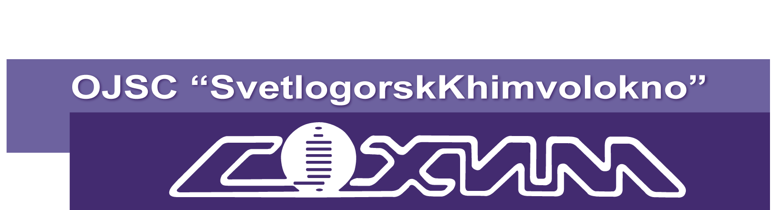
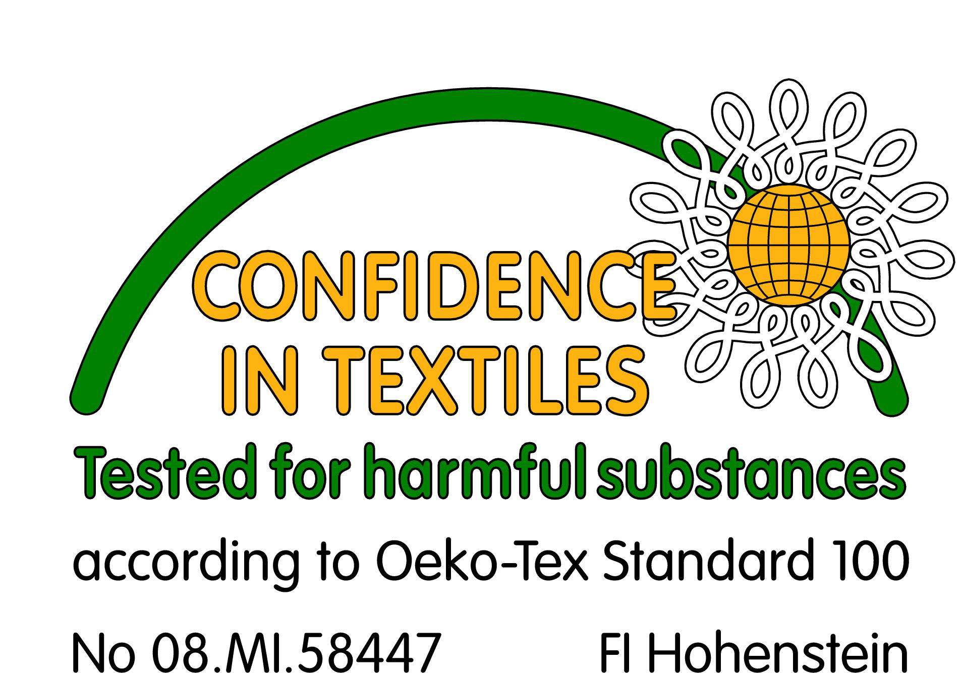

Commercial offer

OJSC “SvetlogorskKhimvolokno” is one of the largest diversified enterprises of petrochemical complex of the Republic of Belarus.
The company has extensive business and trade relations in CIS and far-abroad countries. The geography of export covers more than 40 countries. OJSC “SvetlogorskKhimvolokno” is interested in further development of external commercial relations with business entities from foreign countries.
OJSC “SvetlogorskKhimvolokno” offers the following range of products: polyester textile yarns, nonwoven polypropylene materials, heat-resistant materials “Arselon” and carbon fibers.
Quality management system of manufacture of nonwoven materials is certificated on conformity to the international standard ISO 9001: 2009 and to the standard of management by ecological activity of the enterprise STB ISO 14001:2005. OJSC “SvetlogorskKhimvolokno” has also received international ecological certificate on conformity with Oeko-Tex Standard 100. This certificate applies to textiles, fibers and yarns which are used in the manufacture of textiles, nonwovens and confirms the ecological safety of the products.

Polyester textile yarns. Polyester textile yarns are produced in a wide range of linear densities: 84-167*2 dtex. We can offer the following assortment of the yarns: complex flat and textured, air-entangled, raw white and dyed, fancy blended yarns, yarns with flameproof and antimicrobial additives, heat-resistant yarns.

Commodity code | Product Description | Application
5402330000 | textured polyester textile yarns: undyed and dyed (dope-dyed or superficially dyed), untwisted, twisted, air-entangled, multifilament, non-flammable, with an optical brightener, with an antibacterial additive, crimped yarns | Intended for use in textile industry for production of various tissues and knitted fabrics, curtains, laces and hosiery items, gloves, carpets, basis for faux fur, leather, linoleum, upholstery materials for automotive industry, ropes, ribbons and cords.  Undyed yarns are also intended for manufacture of packaging material used in the food industry if temperature of exploitation does not exceed 100 ° C.
5402470000 | polyester textile complex untwisted and air-entangled yarns including FDY and high shrinkage yarns, with circular cross section and shaped, undyed and dope-dyed, non-flammable
5402520000 | polyester textile complex single yarns with a twist exceeding 50 turns / m with circular cross-sections and shaped, undyed and dope-dyed
5402620000 | polyester textile complex twisted and shaped yarns with effect of floss, frieze, boucle, spiral, caterpillar, etc.

Polyester yarns are available in the form of cylindrical bobbins with a cross-winding. Packaging of finished goods is carried out in cardboard boxes - 8 bobbins, as well as in euro-pallets: 8-10 lines, 6-8 packages in the line.
The cost of polyester textile yarns is within the range of 1,70 – 4,80 $ / kg depending on the assortment.

Non-woven materials. Nonwovens are manufactured by extrusion of continuous polypropylene fibers followed by thermal bonding on calender (SpunBel) or bonding with water at hydro bonding machine (AquaSpun). "SpunBel" materials are produced in a following range of surface density: from 10 g/m2 to 150 g/m2 and with maximum roll width of 3200 mm and 4200 mm. "AquaSpun" materials are produced in a following range of surface density: from 30g/m2 to 250g/m2 and with maximum roll width - 3200 mm. The material is produced dyed and undyed, with UV stabilizer, with an antistatic, hydrophilic, hydrophobic additives and without them. In order to give additional properties a laminating coating of polypropylene or polyethylene can be applied on the materials.

Commodity code | Product Description | Application
5603119000 | nonwovens SpunBel, AquaSpun with surface density no more than 25 g / m² | Applied in the following areas:  Hygiene and Medicine  - Wet and dry wiping cloths, towels, napkins for applying of face masks; upper distribution layers in hygiene products for women and baby diapers, panties, and as a basis for lamination with different kinds of films for the back sheet layer; disposable clothing ( hats, slippers, shoes, shirts, pants, jackets, gowns, face masks, overalls), disposable linens (sheets, pillowcases, diapers, etc.)  Production of building materials:  - As wind-damp-proofing of bearing constructions, as a heat-insulation material in insulated and non-insulated roofs and facades; in the production of waterproofing films as anti-condensate layer; as a cushioning material at floor laying  Furniture trade:  - Cladding of surfaces not covered with decorative cloth, protecting insulation, sheathing of lower and rear walls of mattresses, manufacturing of covers, packaging of independent springs, reinforcement of seams, as a separating layer between upholstery fabric and stuffing and shaping material.  Textile and garment industry:  - Disposable special and industrial clothing, as packing material for the manufacture of decorative products, footwear, etc.  Packing:  - As moisture infiltrating layer in containers for frozen food (meat, vegetable, fruit, etc.)  - Packaging of any product of all industries, including food.  Automotive:  - At manufacture of upholstery fabrics for automotive interiors, protective covers for cars.  Filtering:  -Filters and filtration systems used in liquid and dry environments, including for filtering food liquids.  Agriculture:  - As a covering material to protect plants from unfavorable weather conditions and pests;  - Mulch material for soil  Geotextile:  - In road construction (filter layer, reinforcement of slopes), drainage systems, as a reinforcing layer, as a protective layer when laying geogrids and geomembranes, during the landscape works: laying paving slabs, creation of lawns, beaches, landscapes, etc.
5603129000 | nonwovens SpunBel, AquaSpun with surface density more than 25 g / m², but less than 70 g / m²
5603139000 | nonwovens SpunBel, AquaSpun with surface density more than 70 g / m² but less than 150 g / m²
5603121000 | nonwovens SpunBel, AquaSpun with surface density more than 25 g / m², but less than 70 g / m², laminated | Intended for use in road, drainage and erosion control structures, for manufacturing of protective shelters, covers, shipping containers, packaging for consumer goods, for manufacturing of disposable apparel products used in medicine (napkins, aprons, etc.)
5603131000 | nonwovens SpunBel, AquaSpun with surface density more than 70 g / m² but less than 150 g / m², laminated
5603141009 | nonwovens SpunBel, AquaSpun with surface density more than 150 g / m², laminated

The nonwoven material is wound on paper tubes and packed in plastic or stretch film. The cost of "SpunBel" material (on FCA Svetlogorsk, Belarus) varies in the range of 1,76 – 1,85 $ / kg depending on the assortment. The cost of the "AquaSpun" material is within the price range of 2,50 -3,0 $ / kg.

Heat-resistant fabrics "Arselon". Arselon is poly-oxa-diazole (POD) fiber, possesses specific features for high temperature application. Arselon withstands 250 ºC temperature for long-term using. Oxygen index is 30% minimum.
Arselon range include: filament yarn, staple fiber, technical fabric, spun fabric, nonwoven felt, milled fiber.

Commodity code | Product Description | Application
5402 49 000 0  5402 59 900 0  5402 69 900 0  5401 10 180 0 | Arselon filament yarn  100 tex | automotive hose reinforcement  industrial sealings  composites
5402 49 000 0  5402 59 900 0  5402 69 900 0  5401 10 180 0 |  | sewing thread
5503 90 900 0 | Arselon staple fiber  0.17 tex/ cut length 36 or 51 mm | protective apparel for fireman,  welders
5503 90 900 0 | 0.33 tex/ cut length 66 mm | bag filters for hot gas filtration
5407 91 000 0 | Arselon technical cloth  areal weight 470 g/ sqm,  width 76 cm, 91 cm, 95 cm | shield thermal lining for protective apparel  heat resistant gloves
5503 90 900 0 | Arselon Nonwoven felt  areal weight 500 g/ sqm,  width 100 cm | bag filters for hot gas filtration in cement and metallurgy industries
5503 90 900 0 | Arselon Milled fiber  length up to 2 mm | composites based on phenolic/ epoxy resins
The cost of Arselon materials FCA Svetlogorsk, Belarus:

Arselon staple fiber 21,8-31 $/kg
Arselon filament yarn 100 tex – 26,1-37,5 $/kg
Arselon filament yarn 29,4 tex – 68,5-81 $/kg
Arselon technical cloth – 43,7-68,5 $/ kg

Carbon fiber materials rayon based. Carbon fiber is treated with 2200 ºC and withstands 3600 ºC in vacuum. Rayon carbon fiber is being used in many special applications related with fiber unique properties. Commodity code 6815 10 900 9. Basically there are 7 main features.

Property | Application
Heat resistance and low heat conduction. | Carbon-carbon composites for vacuum furnaces  Graphite felt for thermal insulation
Stable mechanical properties from low to very high temperature range | Sliding bearings, carbon-carbon composites  Reinforcing polyamide and PTFE
High sorption capacity | Water and air filters  Wound care dressings  NBC/ CBRN suits  Super-capacitors
Electrical conductivity | Home and industrial heaters  Infrared quartz heaters  Heating floor and wallpaper
Biocompatibility | Wound care dressings  Carbon-carbon prosthetic devices
Chemical resistance | Vessel lining  Pipeline protection
Electromagnetic interference shielding | EMI-shielding panels  Protective gloves for high-voltage works
The cost of carbon fiber materials depends on its specification.

Polypropylene products. Polypropylene products of OJSC “SvetlogorskKhimvolokno” are produced on the basis of thin-film yarns and they are available in a wide range.

Commodity code | Product Description | Application
5404 90 190 0 | Polypropylene yarn 110 tex. | The yarn is widely used in carpet production also in production of fabric, twine, and for other technical purposes.
5607 41 000 0 | Polypropylene Twine | The twine is used as a binding and dressing material for various purposes
5407 20 110 0 | Polypropylene fabric (non laminated) | Fabric is made of thin-film yarns, plain weave, it can be coloured and uncoloured, laminated and non-laminated, as fabric and sleeve. It is used as packing material in the production of bags, container such as “Bib-Bag”, covers, canvas covers, as waterproofing in the construction, for furniture production and haberdashery, agriculture fabric.
5903 90 990 0 | Polypropylene fabric (laminated)
6305 33 910 1 | Packing bags | Are used for transportation and storing of dry goods sold by the piece with the mass (weight) to 50 kg.
6305 32 810 0 | Rail bags | Rail bags are used for unpackaged transportation of technical sulphur, quicklime, ammoniac saltpeter, silicate sodium, nitric phosphatic fertilizers and other loose and bulk cargo. Use of rail bags increases safety of explosive cargo transportation, protects from external influences, ensures the absence of spillages
6305 32 890 0 | Soft containers of “Big-Bag” type | Are used for the single content storage and transportation of bulk goods with the humidity of no more than15% and of dangerous goods
The cost of polypropylene products on FCA Svetlogorsk, Belarus:

Polypropylene yarn 1,9– 2,8 $/kg.
Polypropylene Twine – 1,7 – 3,0 $/kg.
Polypropylene fabric - 0,17 – 1,4 $/r.m
Packing bags – 0,20 – 24 $/per piece
Rail bags – 78 – 108 $/per piece

In case of interest we shall kindly provide you with more information about our products, their features, applications, and prices.
All products are sold on a pre-paid basis, the delivery of goods transport by the buyer, or transport companies at the buyer's expense. We may provide discounts for a large volume of products.
More information about our products, as well as its technical specifications you can get on our website www.sohim.by, www.arselon.by

Contact information:

OJSC “SvetlogorskKhimvolokno”, the Republic of Belarus, Gomel region, Svetlogorsk, Zavodskaya street, 5. Phone/fax +375234270077/28800; www.sohim.by, www.arselon.by
Polyester textile yarns: phone +375234294000
Head of department – Nikolay Ganjha (ganjha@sohim.by).
Nonwoven materials and polypropylene products: phone +375234294025;
Head of department –Irina Kriskovets (i.kriskovets@sohim.by, spunbond@sohim.by).
Marina Kazak - +3752342 95244 (kazakm@sohim.by)
Special fibers (Carbon Fibers, “Arselon”): +37523424976
Head of division – Kirill Yakovlev (yakovlev@sohim.by; export@sohim.by).

