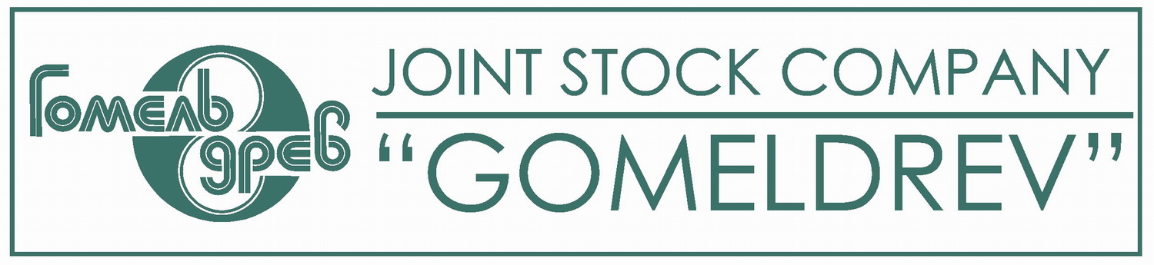

Dear Sirs!
JSC "Gomeldrev" is one of the largest and oldest furniture manufacturers in Belarus. Success and recognition of the products with the trademark "Gomeldrev" promotes trade and dealer network, which includes representatives from the regions of the Commonwealth and Belarus. The main products of "Gomeldrev" that represent the brand of the enterprise - is furniture made of natural wood and wood materials, using ecologicaly friendly materials, high-quality components and accessories of leading manufacturers.

Cabinet furniture made of solid oak and birch is in special demand (HS Code 9403609000). Real masterpieces are created by combination of audacity of designers' imagination and the professionalism of the staff, the usage of new and traditional materials and modern production technologies. A great deal of customers got acquainted with elite product collections “Falcone“, “Versailles "Prestige", "Versailles", "Bosphorus", "Kyoto". "Trend", "Brent", "Amelia", "Calypso", "Majorelle", which became a kind of company’s real trademark, a numerous sets of bedroom furniture, a wide range of halls, furniture for living room, office, as well as tables, chairs, cupboards and cabinets for various needs.

Years of experience in the furniture manufacturing, using the current technology, new design development and quality standards allows the company to increase its sales in the domestic market and to work successfully to expand the geography and to increase the exports. Our company has been keeping good business and friendly relations with many partners for a long time.
The main production of JSC "Gomeldrev" – is the furniture made of wood and wood products, designed for the furnishing the different areas of human habitation in residential and public buildings. For operational purposes, furniture is divided into furniture for homes or for public buildings, according to functional purpose it can be divided into store furniture (cabinet), furniture for work and meals, seating furniture, furniture for lying. The high level in organizing the production is approved by ISO 9001-2000 quality management, achieved in 2005.
Besides furniture JSC "Gomeldrev" produces baguette (HS Code 4421909800). Baguette is molding of the length from 0.4 to 3.0 meters, and is used for framing paintings, drawings, mirrors and pictures.

Also, on March 22nd 2013, the Joint stock company "Gomeldrev" received the FSC certificate, which allows our company to sell our products in the European Union.
And also The Joint stock company "Gomeldrev" produces the complete sets of panels for houses of frame type on the hi-tech equipment of the firm "Mitek" (HS Code 9406002000). Frame systems are made from qualitative coniferous timber which is addiced, wood preservatived and of chamber drying. Building of frame houses is one of the most perspective technologies of the low-rise building. As a heat-insulated materials is used the heater «PAROK». The thermal protection layer in 150 mm completely provides all-the-year-round comfortable residing. As wind and vapour protection are applied special vapour protection films. The design of the wall panels allows to mount the house operatively and without the large expenses. Houses of such type are assembled as a construction set by a brigade of 4-7 persons in a current of week. In wooden houses of a frame design, as well as in houses from a bar, a log and a brick, it is possible to install stoves or fireplaces. Such wooden frame houses are harmless, they combine the tested quality of natural materials with the advantage of application of scientific developments in building.

Nowadays we release Plywood for general purposes with outer layers of hardwood veneer (HS Code 4412320000). By the degree of water resistance we produce waterproof plywood. According to the degree of machining our plywood is subdivided into unsanded and sanded, produced from birch, alder, as well as the grade of I / I to IV / IV. Netherlands companies with whom we have had a positive experience in cooperation on the sale of plywood – are International plywood, Neymann, Dragmire Trading. With these companies we would like to continue the cooperation.

JSC "Gomeldrev" produces the matches of the format 2/3 and non-format for home use (HS Code 3605000000). Matches of the format 2/3 are filled with 45 pieces, issued in accordance with GOST 1820-2001. Matchbox has a decoration of labels that is created by printing.

JSC "Gomeldrev" produces softwood lumber cut with a thickness of 50mm, the width exceeding 150 mm, grade is from 1 to 4, of a natural moisture. Length of lumber produced by us is 4 meters (HS Code 4407109300).

And also "Gomeldrev" produces boards for flooring planed on both sides used for transparent and opaque coating, of the 27mm thickness, 105mm width and of the length of 4-6 meters (HS Code 4409101800).
Besides above products of JSC "Gomeldrev" produces floorboard and varnished parquet piece produced from the array size 300 1200h90h15. The variety of color scale represented by the following colors, natural oak, oak vanilla, oak walnut, oak charcoal, ash and natural vanilla (HS Code 4418720000).

A new kind of product "Gomeldrev" is going to produce is MDF plate (HS Code 4411140000). MDF is used in the manufacture of furniture, for decoration of the rooms, as wall panels, ekonompanels for shop premises and laminate flooring. JSC "Gomeldrev" plans to produce polished MDF board of the thickness from 3 to 40 mm, the size of plates: 2800h2070 mm, laminated MDF board the thickness from 10 to 25 mm, the size of plates: 2800h2070 mm.

Also JSC "Gomeldrev" plans to release HDF boards (HS Code 4411920000), for further manufacture of laminated floor panels (8 mm), wear group: 32-33, the presence of moisture-resistant impregnation. (HS Code 4411130000). In the production of laminate floor "Gomeldrev" is going to use interlock 2G license from the world's leading distributor - the company UNILIN.

After signing the contract the discounts may be provided. It depends on the method of payment, the amount and the size of the order. The basis of price formation is the FCA (the goods are delivered to the carrier of the customer).
Depending on the variety of furniture the delivery can range from 10bedrooms to 200 bedrooms tables, which is the maximum party of goods.
We carry out our products through a stock exchange as well as through direct talks.

We were interested in every business proposal.
We offer you the products that can be found at our web-site: www.gomeldrev.by
Prices for the products in U.S. dollars and Euro are in the price list (attached).
It is also included the information about the products and its description.
Our Contact Address
The Republic of Belarus, Gomel, ul.Dostoevskogo, 3.
e-mail: ves@gomeldrev.gomel.by
Tel. +375232 37 50 75

