Мiнiстэрства прамысловасцi  Рэспублiкi Беларусь  Холдынг «БЕЛАЎТАМАЗ»  Адкрытае акцыянернае таварыства  «Баранавiцкi аўтаагрэгатны завод»  (ААТ «БААЗ»)  вул. Гагарына, 62, 225409, г.Баранавічы  Брэсцкай вобл., Рэспубліка Беларусь  Тэл.(0163) 45 08 00 (дырэктар, прыемная),  Факс 45 08 01  Тэл./факс (0163) 45 08 05 (аддзел маркетынгу),  (0163) 45 07 85 (аддзел продаж)  www.baaz.by e-mail: baaz@baaz.by  УНП 200167349  Р/р BY56 AKBB 3012 6037 4001 2130 0000  у ЦБП №127 ААТ «ААБ Беларусбанк»  г. Баранавічы, бульвар Штакерау, 8а  БІК AKBBBY2Х АКПА 002316271000 |  | The Ministry of Industry  of the Republic of Belarus  Holding Company «BELAUTOMAZ»  Open Joint Stock Company  «Baranovichy Automobile Units Plant» («BAUP» OJSC)  62 Gagarin Str., Baranovichi,  Brest region, Republic of Belarus, 225409  Tel. (+375 163) 45 08 00 (director, reception room),  fax . (+375 163) 45 08 01  Tel./fax . (+375 163) 45 08 05 (marketing department),  (+375 163) 45 07 85 (sales department)  www.baaz.by e-mail: baaz@baaz.by  UNP (Taxpayer identification number) 200167349  Bank account number BY56 AKBB 3012 6037 4001 2130 0000  In Banking Services Centre №127  JSC “Savings Bank BELARUSBANK”  8a Stockerau Boulevard, Baranovichi  BIC AKBBBY2Х OKPO 002316271000
Commercial offer

Baranovichy Automobile Units Plant («BAUP» OJSC) is a Belarusian enterprise specializing in the production of spare parts for trucks, buses, trolleybuses, trailers and semi-trailers, and railway transport.
The plant is known as the official supplier of original components for the assembly lines of MAZ, BELAZ, Gomselmash, Belkommunmash, GAZ, KAMAZ, URAL, Rostselmash, PAZ, LiAZ, as well as for the auto components market. The plant's product range includes more than 1,700 items for both domestic and imported vehicles VOLVO, MAN, SCANIA, DAF, MERCEDES-BENZ, IVECO, SITRAK HOWO, SHACMAN, BPW, SAF, SCHMITZ, etc.
The quality management system of «BAUP» OJSC complies with ISO 9001:2015 and IATF 16949:2016 standards. All components undergo testing and quality checks.

Products of «BAUP» OJSC

Picture | Description
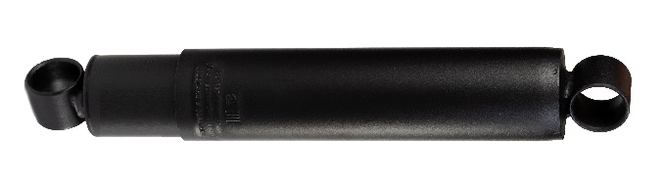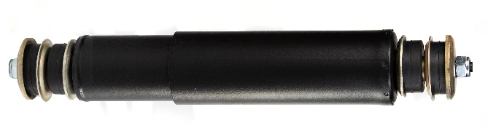 | Two-tube hydraulic telescopic shock absorbers  Designed to dampen vibrations of the body and wheels arising during the movement of motor vehicles of categories M, N, O, T.  Applicability: all types of cargo vehicles and buses  HS Code: 8708803509
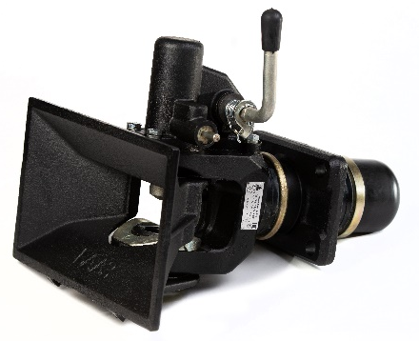 | Trailer couplings  Designed for non-lock chaining of vehicles with a towed trailer, complies with the requirements of UNECE Regulation №55-01 EEC UN.  Applicability: all types of cargo vehicles and agricultural machinery.  HS Code: 8708299009
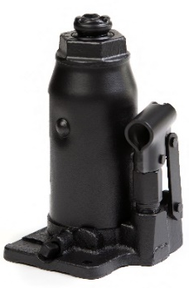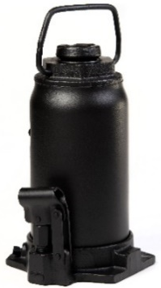 | Hydraulic jacks  Designed for lifting one of the vehicle parts during repair and maintenance.  HS Code: 8425420000
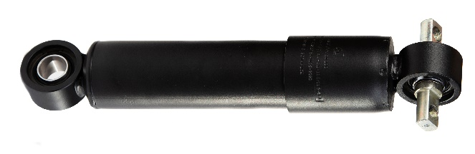  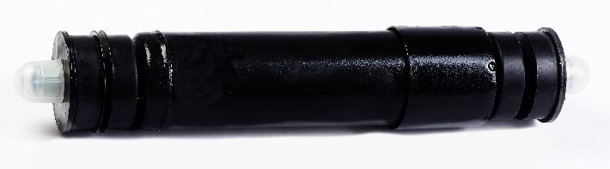 | Double tube telescopic hydraulic shock absorbers and dampers  Designed to be installed in the axle box stage of spring suspension of locomotives (diesel locomotives, electric locomotives) in order to ensure regulated smoothness and impact on the rail track.  Applicability: diesel locomotives, electric locomotives.  HS Code: 8607998000
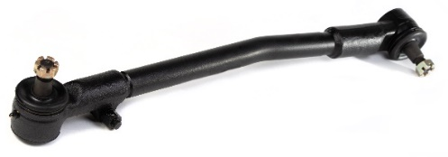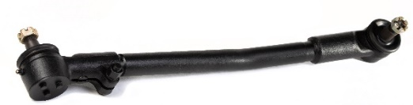 | Steering rods  Designed to transfer force from the steering gear to controlled wheels of vehicles of categories M, N.  Applicability: all types of cargo vehicles and buses  HS Code: 8708949909
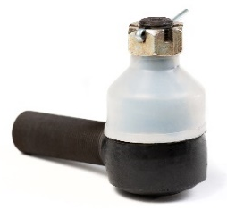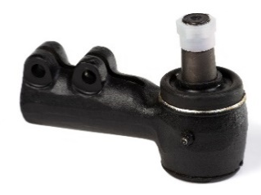 | Steering rod tips  Used as part of the steering systems of motor vehicles and are designed to transfer force from steering traction to controlled wheels of vehicles of categories M, N, O.  Applicability: all types of cargo vehicles and buses  HS Code: 8708949909
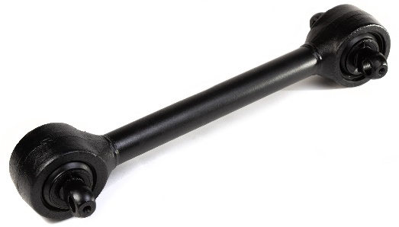 | Reactive rods  Designed to transmit reactive and braking moments, pushing forces from bridges to the frame or body of vehicles.  Applicability: all types of cargo vehicles and buses.  HS Code: 8708809909
We invite you to consider our offer in the field of deliveries of our manufactured products, units and components for trucks and buses, as a direct buyer or dealer. There is a system of discounts, including depending on the distance of the region. The terms of delivery and the procedure for payments are negotiated by the parties.
You can see the full catalog of products on the official website www.baaz.by.

Contact Information:
Gagarin st., 62, Baranovichy, Republic of Belarus.
Marketing department: +375 (163) 45-08-05, 45-08-03, e-mail: marketing@baaz.by Viber, WhatsUp: +375 (29) 633-99-98

