 | Open joint-stock company  “Glubokoe dairy-canning factory”

Open joint-stock company “Glubokoe dairy-canning factory” is one of the largest manufacturers of dairy products both in the Republic of Belarus and in the countries of the CIS with modern facilities, involved in the processing and packaging of a wide variety of canned milk. “Glubokoe dairy-canning factory” was built and equipped to meet all international standards within the food industry. Using of high-quality ingredients corresponding to European Standards, unique quality control system of finished products over all processes of production aimed at exact compliance with approved standards ISO 9001-2009 and of course long traditions are the basis of success.
Range of products manufacturing at our factory includes following groups:
- condensed canned milk;
- evaporated milk;
- milk powder;
- butter;
- cheese;
- whey.
Products are ready for human consumption. Also they can be used in food, bakery, confectionery industry, etc.
Important competitive advantages of OJSC “Glubokoe dairy-canning factory” are
• high quality;
• using of natural raw materials;
• modern equipment from leading manufacturers;
• clear positioning in the market.

The product quality corresponds to technical regulations for milk products. All products of the factory are certified. There are certificates of conformity HACCP, ISO, HALAL, FSSC.
The products of OJSC “Glubokoe dairy-canning factory” are delivered to the markets of Russia, Kazakhstan, Azerbaijan, Tajikistan, Israel, Georgia, Turkmenistan, Armenia, Uzbekistan, Kyrgyzstan, Moldova, China, UAE, Algeria, Lebanon.
We hope the products of our factory can compete with the goods presented in your market.
More detailed information about our factory you can find on our web-site www.glmkk.by.
We are sure contacting us you find a reliable and long-term partner.

15.05.2026
Description of goods | photo | H.S. code | Quantity in a carton (pieces) | Shelf life | Unit Price FCA Glubokoe,  USD
Sweetened condensed full cream milk 8,5% fat, tin can 380g. | 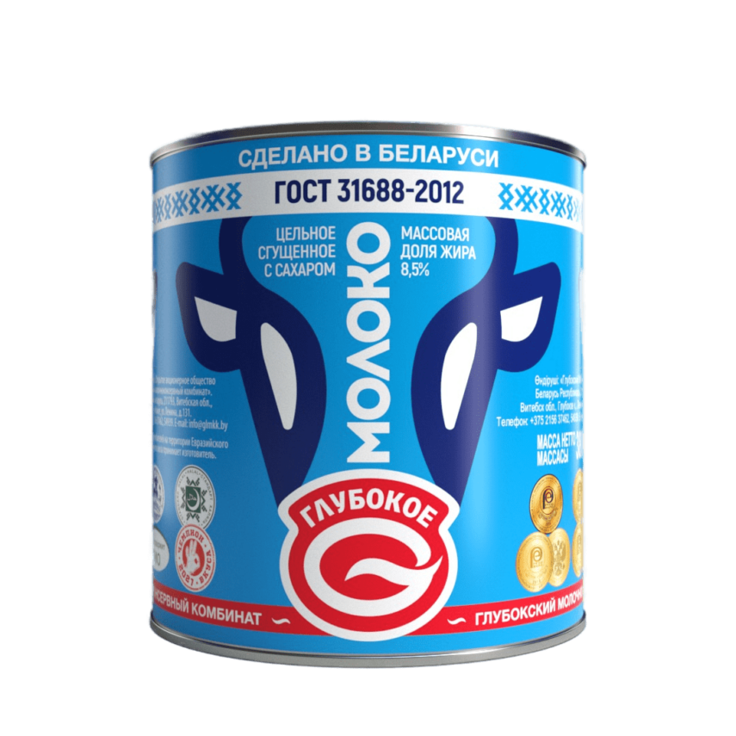 | 0402991000 | 30 | 18 | 1,00
Sweetened condensed full cream milk 8,5% fat, tin can 380g. with easy open end |  | 0402991000 | 30 | 18 | 1,05
Sweetened condensed full cream milk 8,5% fat, pouch 280g. |  | 0402991000 | 24 | 12 | 0,80
Evaporated full cream milk 8,6% fat, tin can 300g. | 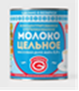 | 0402913000 | 45 | 18 | 0,73
Sweetened condensed boiled milk “Lakomka” 8,5% fat, tin can 380g. | 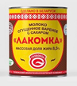 | 0402991000 | 30 | 10 | 1,15
Sweetened condensed milk with natural coffee 7,5% fat, tin can 380g | 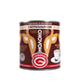 | 1901909800 | 30 | 12 | 1,50
Sweetened condensed milk with chicory 7,0% fat, tin can 380g |  | 1901909800 | 30 | 12 | 1,10
Sweetened condensed milk with cocoa 7,5% fat, tin can 380g | 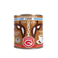 | 1806909000 | 30 | 12 | 1,30
Sweetened condensed milk with cocoa, 7,5% fat, pouch 280g. | 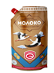 | 1806909000 | 24 | 12 | 1,00
Sweetened condensed milk with flavor “Cherry brandy” 8,5% fat, tin can 380g | 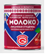 | 0402991000 | 30 | 12 | 1,10
Sweetened condensed milk with flavor “Spearmint” 8,5% fat, tin can 380g | 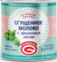 | 0402991000 | 30 | 12 | 1,10
Sweetened condensed milk with flavor “Cherry brandy” “Cherry covered with chocolate” 8,5% fat, tin can 380g | 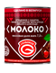 | 1806909000 | 30 | 10 | 1,25
Sweetened condensed milk with flavor “Cherry brandy” “Cherry covered with chocolate” 8,5% fat, pouch 280g. | 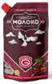 | 1806909000 | 24 | 6 | 1,00
Sweetened condensed cream 19%fat, tin can 360g | 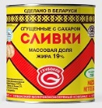 | 0402993100 | 30 | 14 | 1,30
Sweetened condensed cream 19%fat, pouch 280g | 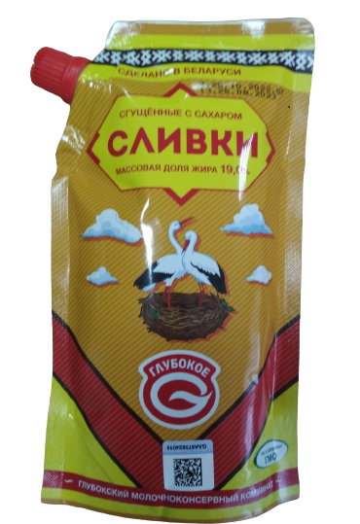 | 0402993100 | 24 | 10 | 1,05
Sweetened condensed fat-filled whey product “Sgushchenka tvoya” 8,5% fat, tin can 380g | 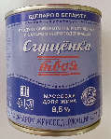 | 0404100400 | 30 | 12 | 0,65
Full cream milk powder 26% fat, bag 25 kg | 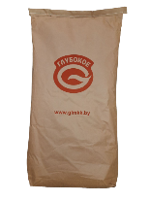 | 0402211800 | 1 | 24 | 3,00 /  (1 kg)
Full cream milk powder 26% fat, 500g (zip package) | 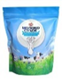 | 0402211800 | 16 | 24 | 3,10
Sweet cream unsalted butter 82.5%, 20kg | 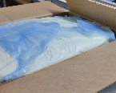 | 0405101900 | 1 | 15 | 4,50 /  (1 kg)
Delivery terms: FCA Glubokoe, Vitebsk region
Payment terms: 100% advance payment
131 Lenina str., Glubokoe, Vitebsk region, 211793, the Republic of Belarus
www.glmkk.by
Тел.: +375215637481
General Director: Valery B. Dulinsky
Foreign Trade Activity Department: +375215637462, +375215654902.
E-mail: yulia@glmkk.by
Contact person: Yulia Smolskaya

