Dear Sirs!

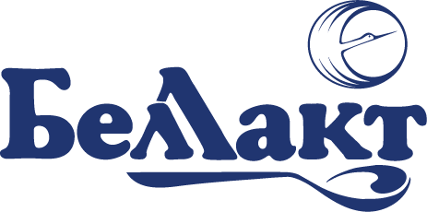 | OJSC «Holding management company «Grodnomyasomolprom»  Volkovysk Open Joint Stock Company «Bellakt»  230415, Republic of Belarus, Grodno Region, Volkovysk,  Oktyabrskaya Str., 133  Reception: +375 (1512) 7-50-25, fax: 7-50-26  e-mail: bellakt@bellakt.com  Account: BY55BAPB30122903300140000000 in OJSC «Belagroprombank», Minsk  SWIFT BAPBBY2X, Tax Identification Number 500043093, OKPO 00418320  ___________________________________________________________________
_31.12.2025_ № _______________  на № ___________ от ________________ | ОАО «Управляющая компания холдинга «Гродномясомолпром»  Волковысское открытое акционерное общество «Беллакт»  230415, Республика Беларусь, Гродненская область, г. Волковыск,  ул. Октябрьская,133.  Приёмная руководителя: (+375 1512) 7 50 25; факс: 7 50 26  e-mail: bellakt@bellakt.com  Р/с BY55BAPB30122903300140000000 в ОАО «Белагропромбанк» г. Минск БИК BAPBBY2Х, УНП 500043093, ОКПО 00418320
It is my utmost privilege to extend greeting to you on behalf of a large manufacturer of high quality dry milk products from Belarus, Eastern Europe.
Volkovysk OJSC “Bellakt” is the only producer of powdered baby food products and the leading dairy processing company in the Republic of Belarus.
Company founded in 1970 and located in an environmentally clean area, boarding on the National reserve park “Bialowieza Forest”, one of the UNESCO World Heritage sites. Nowadays Volkovysk OJSC “Bellakt” is a well-known brand, backed with high-tech, large-scale production facilities, whose success is rooted in strong traditions and respect to heritage. We are a stable and fast growing company exporting over 40% of our products.
The high competitive advantage of our products is the result of a certified quality management system that meets international standards. The quality control is guaranteed by our own accredited testing center. The quality of our products has been confirmed by numerous international awards and certificates. The production is certified according to ISO 9001-2015, FSSC 22000, HACCP STB 1470-2012, Halal etc.
Our price offer is below (FCA Volkovysk):
№ п/п | Name (age for nutrition) | Unit price, U.S. dollar
1 | Whole milk powder 26 % fat, in a zip-lock package (doy-pack) 400 g | 1,80
2 | Whole milk powder 26 % fat, in tin 400 g | 2,80
3 | Whole milk powder 26 % fat, in bags 25 kg | 2,90 (for 1 kg)
4 | Skimmed milk powder, in a zip-lock package (doy-pack) 400 g | 1,25
5 | Skimmed milk powder, in tin 400 g | 2,15
6 | Skimmed milk powder, in bags 25 kg | 2,40 (for 1 kg)
7 | Sweet unsalted butter 82,5 % fat, in blocks of 20 kg, frozen, shelf life 15 months | 4,5 for 1 kg
8 | Sweet unsalted butter 72,5 % fat, in blocks of 20 kg, frozen, shelf life 15 months | 3,9 for 1 kg
9 | Sweet unsalted butter 82,5 % fat, in polyfoil of 180 g, frozen, shelf life 120 days | 1,00 for 1 pack
10 | Infant formula "Bellakt 1", tin can, 400 g | 2,85
11 | Follow-up infant formula "Bellakt 2", tin can, 400 g | 2,85
12 | Growing-up infant formula "Bellakt 3", tin can, 400 g | 2,75

- The product quality meets the standard specification of the buyer or seller
- Payment terms: 100% prepayment

If you are interested, you can find out more about our company on the website:
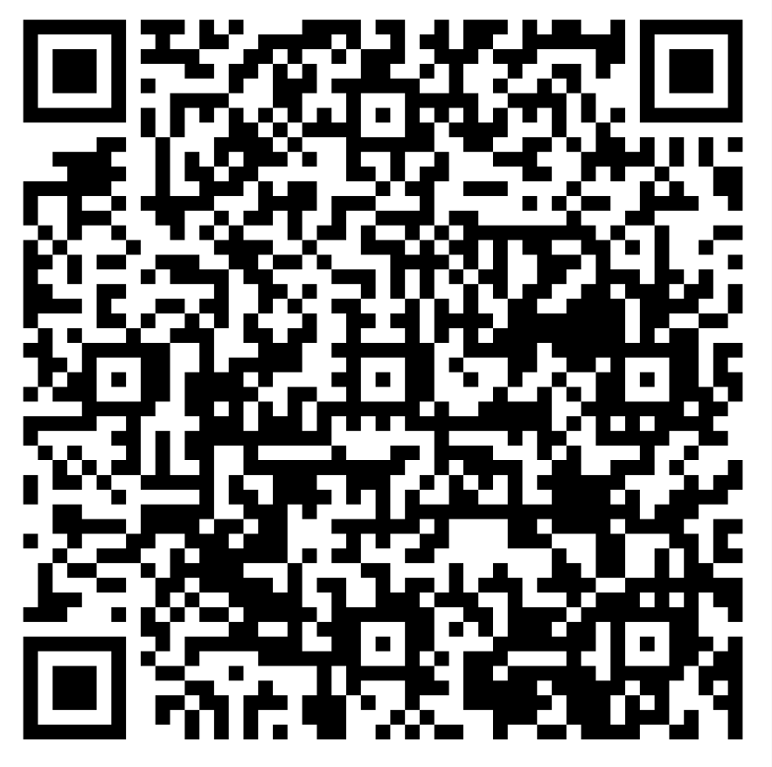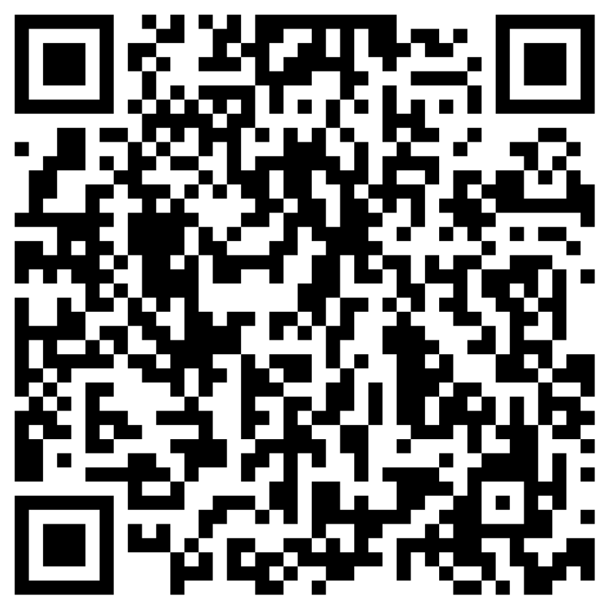
www.bellakt.com quality system bellakt export

And we are always ready to promptly answer all your questions and discuss possible options for cooperation.
Yours faithfully,
Illia Karahodau
Senior Export Manager
Volkovysk OJSC “Bellakt”
Tel. +375-1512-75030, +375447660056 (mobile)
e-mail: export@bellakt.com

